Task 2
Select ONE prototyping approach (Evolutionary Prototyping or Throwaway Prototyping). Develop low-fidelity prototypes for 3 main screens of the system and justify why your chosen approach is more appropriate for this project. [2 marks]

2.1 Selected Approach: Evolutionary Prototyping
For the SAMS project, we selected Evolutionary Prototyping. In this approach, we start by developing the important parts of the system, then users test the prototype and give their feedback. After that, we keep improving it until the prototype become the final working system. The prototype is not deleted like Throwaway Prototyping.
This approach is more suitable for SAMS because:
- SAMS is a new system, so some requirements may not be clear from the beginning. When students and staff test the prototype, they may remember new requirements or ask to change some parts.
- The system has different users, such as students, organizers, and Student Affairs staff. Each user may have different needs, so their feedback will help us improve the screens and functions.
- Some functions need more testing, like the waiting list, QR attendance, eligibility rules, and approving activities. It is better to build these parts early and improve them step by step.
- The prototype can show if the screens are crowded, confusing, or difficult to use. For example, users can test the activity search, seat reservation, and activity management screens before completing the whole system.
- The work will not be wasted because every improved version can be used in the final SAMS system. This is better for our project because the development time is limited.
For these reasons, Evolutionary Prototyping can help us understand the requirements better and build a system that is more useful for the actual users.

2.2 Prototype 1 — Student: Browse Activities
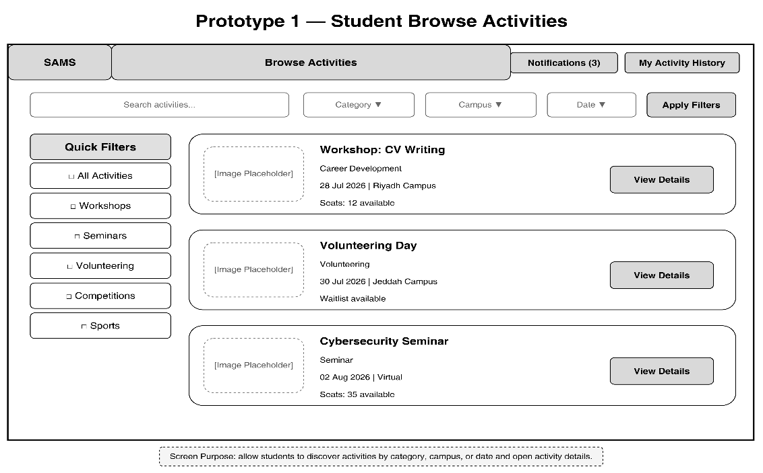
Figure 2 Prototype 1 — Student: Browse Activities

2.3 Prototype 2 — Activity Details and Reservation
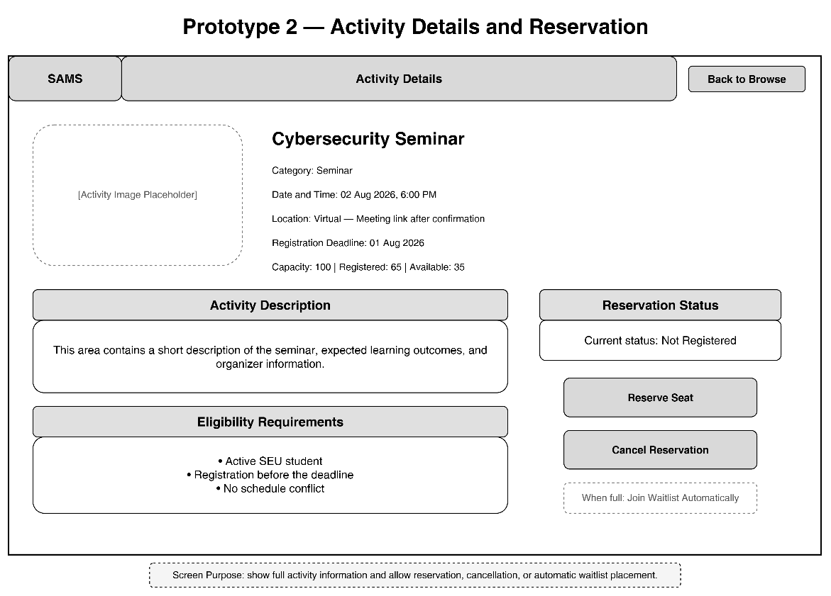
Figure 3 Prototype 2 — Activity Details and Reservation

2.4 Prototype 3 — Organizer Activity Management
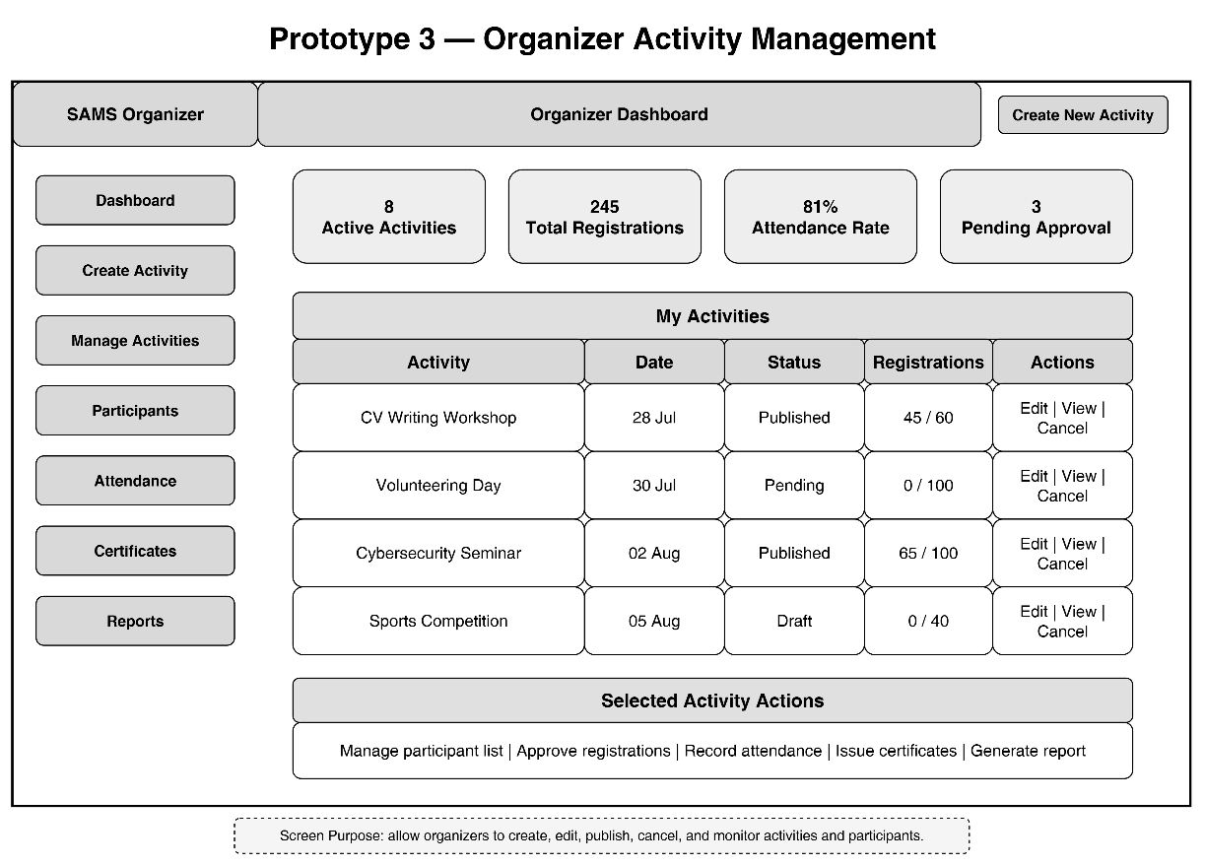
Figure 4 Prototype 3 — Organizer Activity Management

Enhanced Evolutionary Features & Workflow
1. User Feedback Integration:
• Quick Feedback Collection: Students and organizers evaluate the three main screens directly to provide immediate usability insights.
• Direct Modification: Instant adjustments are made to screen layouts, button placements, and text clarity based on user preferences.
• Incremental Building: Accepted screens are continuously improved to gradually become part of the final system without starting from scratch.
2. Core Simplified Functions:
• Simple Immediate Alerts: Clear notifications on the main screen to alert students about available seats or new activity registrations.
• One-Click Booking: A direct button allowing students to reserve a seat and instantly view their entry pass/ticket.
• Simplified Activity Filtering: Basic filter options (by category, department, or date) to help users find suitable activities quickly.
3. Core Operational Workflow:
• Main User Actions: Browsing and filtering student activities, registering for activities, receiving confirmation passes, viewing the participant list, and updating activity status (for organizers)

